http://www.threadsmagazine.com/assets/uploads/posts/5149/BlankGrid_xl.jpg

Threads Magazine Find Your Best Silhouette
January 7th, 2009 in design, online extras

Modified by KharminJ, 1-26-09

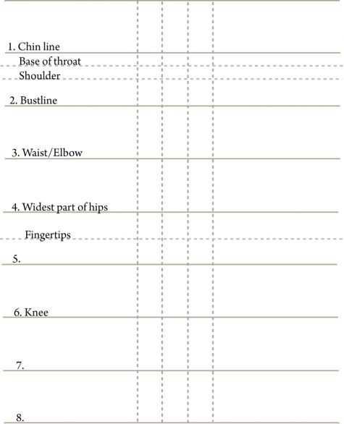

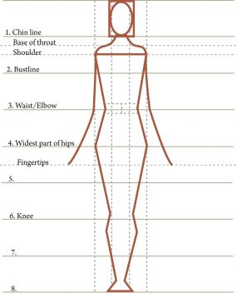

Ideal proportions, using the Golden Ratio ~ 1:1.6 or 3:5

Put your head here

Compare actual locations to “ideal” lines

“Ideal” is 7.5 to 8
head heights - floor to top of head

