Easy Fabric Ponchos
Courtesy of Jo-Ann Stores, Inc.
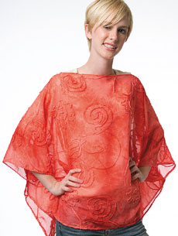
Fast, fun and fashionable! Add a quick touch of style to your wardrobe with these easy fabric ponchos!

Skill Level: Some sewing experience helpful. Approximate Crafting Time: 1 hour per shawl.

See diagram Easy Fabric Ponchos.pdf

Rectangle Poncho
Materials: 1-1/2 yds. 54" wide fabric

Directions
- Fold fabric in half with selvages together. Measure across fold line and cut at 49". (Folded piece will then measure 49"x 27").
- On folded edge center a 12" cut for neck opening.
- Finish neck opening with a rolled edge hem.
- Finish around entire shawl with rolled edge hem.
- With wrong sides together, measure down the sides 10” from fold . Stitch to a 5" line in from edge for armhole. Repeat for other side.

Triangle Poncho
Materials: 2 yds. 45" fabric
Directions
- Fold fabric in half lengthwise.
- Measure across bottom edge to center 22-1/2" and mark.
- Lightly mark a line from the folded edges to the bottom center mark.
- Cut along this line.
- On fold of fabric center a 12" cut for neck opening. Finish neck opening with a rolled edge hem.
- Finish around entire shawl edge with a rolled edge hem.
- With wrong sides together, measure from fold along edge 13" down for arm placement. Stitch 4" in on both edges for armhole.

Nothing on this page --see the accompanying .pdf file for diagrams

