Burda 8143 PantSuit
PantSuit
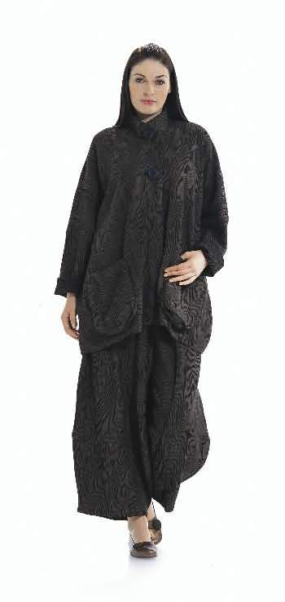
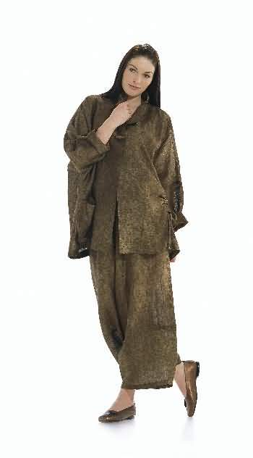
Line Drawing
Size Chart
Top, Suits / Separates, Pant, Plus
Buy it for $10.95 $

